Devops Project 2

Section 1: (Project code Github link, Infrastructure Github link)
- Install latest AWS CLI
- Run awsconfiger command to config with AWS, download a new pem file and give that pem file name in the terraform scripts.
- Install Terraform in local, all manifest files are pushed to github, execute this script under V6-EC2-Jenkins-port.tf to provision the aws infrastructure. cmd is
- “terraform init”
- “terraform plan”
- “terraform apply --auto-approve”
- “terraform destroy –auto-approve”
Section 2:
- Install Ansible in ansible-server
- Add Inventory
- vi hosts
- ------
- [jenkins-master]
- 10.1.1.242

- [jenkins-master:vars]
- ansible_user=ubuntu
- ansible_ssh_private_key_file=/opt/dpp.pem

- [jenkins-slave]
- 10.1.1.190

- [jenkins-slave:vars]
- ansible_user=ubuntu
- ansible_ssh_private_key_file=/opt/dpp.pem
- ------
- Copy private key to ansible, for that create a s3 bucket, upload the file in the s3 bucket, click on the file, under action/preassigned url, copy the generated url, go to the ansible as root user and apply below commands
- cd /opt
- wget -O dpp.pem “preassignedurl”
- chmod 400 dpp.pem -> remove the write permissions
- Test the connection
- ansible all -i hosts -m ping
- Write Ansible playbook to install jenkins
- %%%%%%%%%%%%%%%%%%%%%%%%%%%%%%%%%%%%%%%%%%%%%%%%
- ---
- - hosts: jenkins-master
- become: true
- tasks:
- - name: add jenkins key
- apt_key:
- url: https://pkg.jenkins.io/debian-stable/jenkins.io-2023.key
- state: present

- - name: add jenkins repo
- apt_repository:
- repo: 'deb https://pkg.jenkins.io/debian-stable binary/'
- state: present

- - name: install java
- apt:
- name: openjdk-11-jdk
- state: present

- - name: install jenkins
- apt:
- name: jenkins
- state: present

- - name: start jenkins service
- service:
- name: jenkins
- state: started

- - name: enable jenkins to start at boot time
- service:
- name: jenkins
- enabled: yes
- %%%%%%%%%%%%%%%%%%%%%%%%%%%%%%%%%%%%%%%%%%%%%%%%
- Run Ansible playbook to install jenkins
- ansible-playbook -i hosts jenkins-master.yaml
- Go to Jenkins-master instance and configure jenkins server
- Installing maven and java in jenkins-slave, Write Ansible playbook to install maven in slave. Try install jdk17 in jenkins-slave server if playbook cant install it, install it manually.
- %%%%%%%%%%%%%%%%%%%%%%%%%%%%%%%%%%%%%%%%%%%%%%%%%%
- ---
- - hosts: jenkins-slave
- become: true
- tasks:
- - name: update ubuntu repo and cache
- apt:
- update_cache: yes
- cache_valid_time: 3600

- - name: install java
- apt:
- name: openjdk-11-jre
- state: present

- - name: download maven packages
- get_url:
- url: https://dlcdn.apache.org/maven/maven-3/3.9.5/binaries/apache-maven-3.9.5-bin.tar.gz
- dest: /opt

- - name: extract maven packages
- unarchive:
- src: /opt/apache-maven-3.9.5-bin.tar.gz
- dest: /opt
- remote_src: yes%%%%%%%%%%%%%%%%%%%%%%%%%%%%%%%%%%%%%%%%%%%%%%%%%%

Section 5: JENKINS

Setup Jenkins master slave configuration.
Add credentials
Add node
Add Credentials
- Manage Jenkins --> Manage Credentials --> System --> Global credentials --> Add credentials
- Provide the below info to add credentials
- kind: ssh username with private key
- Scope: Global
- ID: maven_slave
- Username: ec2-user
- private key: dpo.pem key content
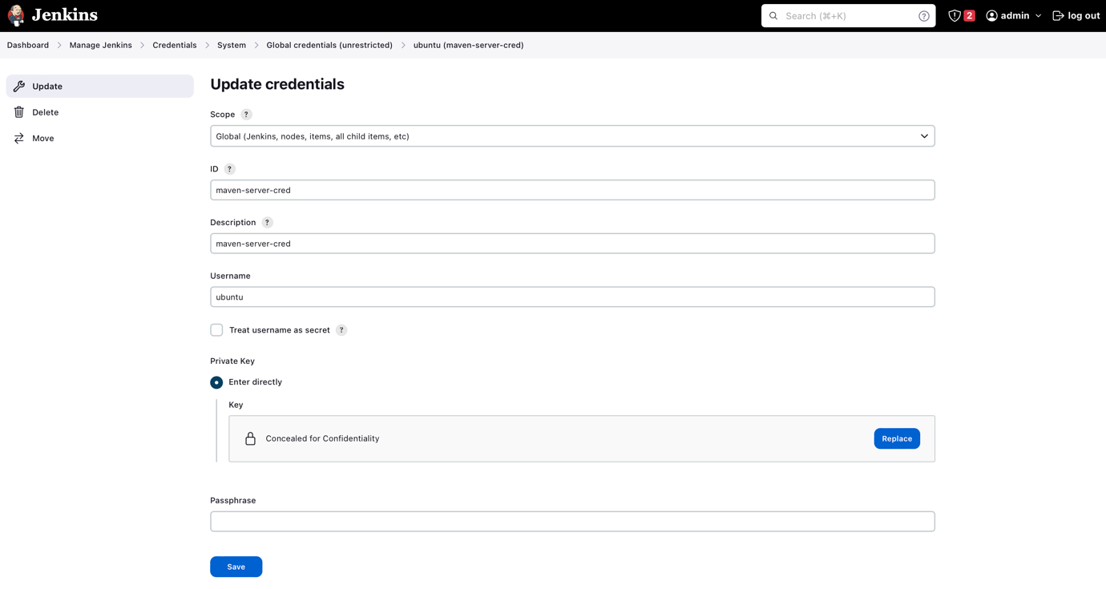

Add node
Follow the below setups to add a new slave node to the jenkins
- Goto Manage Jenkins --> Manage nodes and clouds --> New node --> Permanent Agent
- Provide the below info to add the node
- Number of executors: 3
- Remote root directory: /home/ubuntu/jenkins
- Labels: maven
- Usage: Use this node as much as possible
- Launch method: Launch agents via SSH
- Host: <Private_IP_of_Slave>
- Credentials: <Jenkins_Slave_Credentials>
- Host Key Verification Strategy: Non verifying Verification Strategy
- Availability: Keep this agent online as much as possible

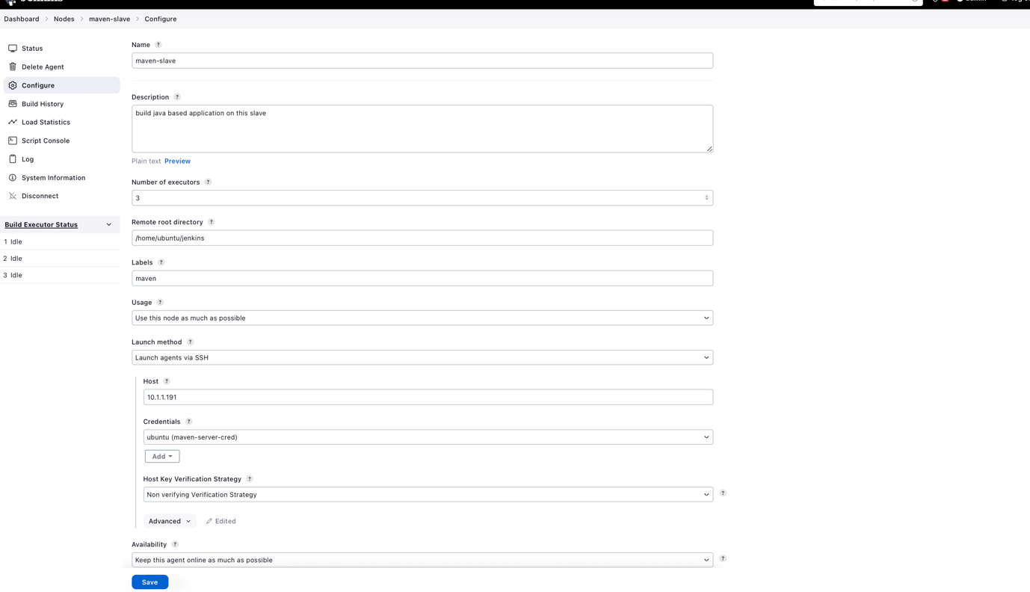

Create a first jenkins pipeline job

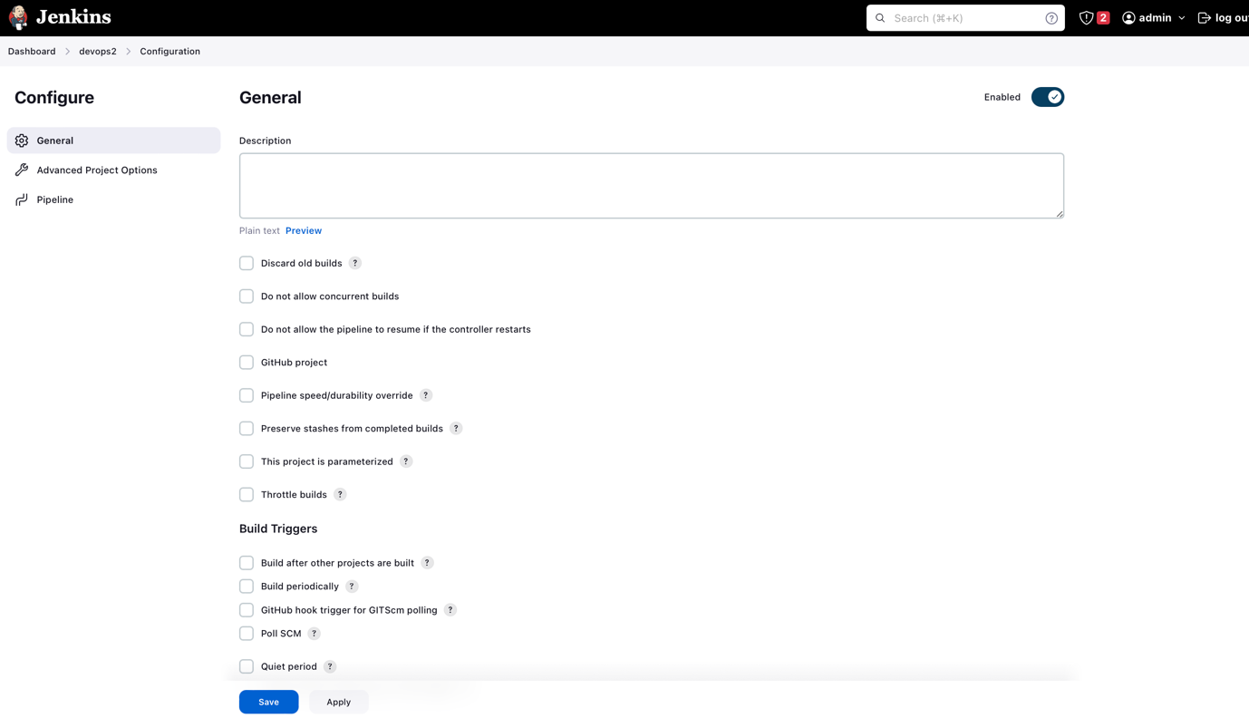

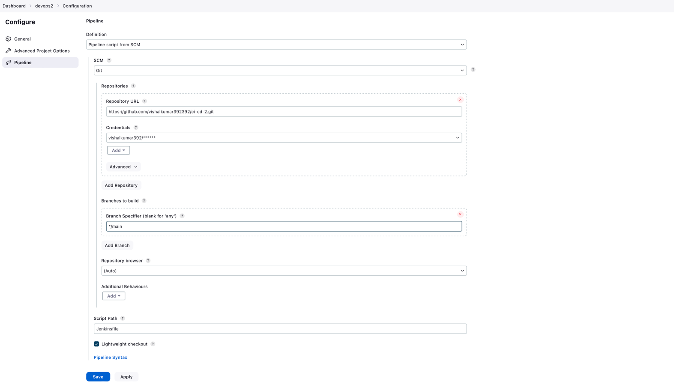

Jenkinsfile

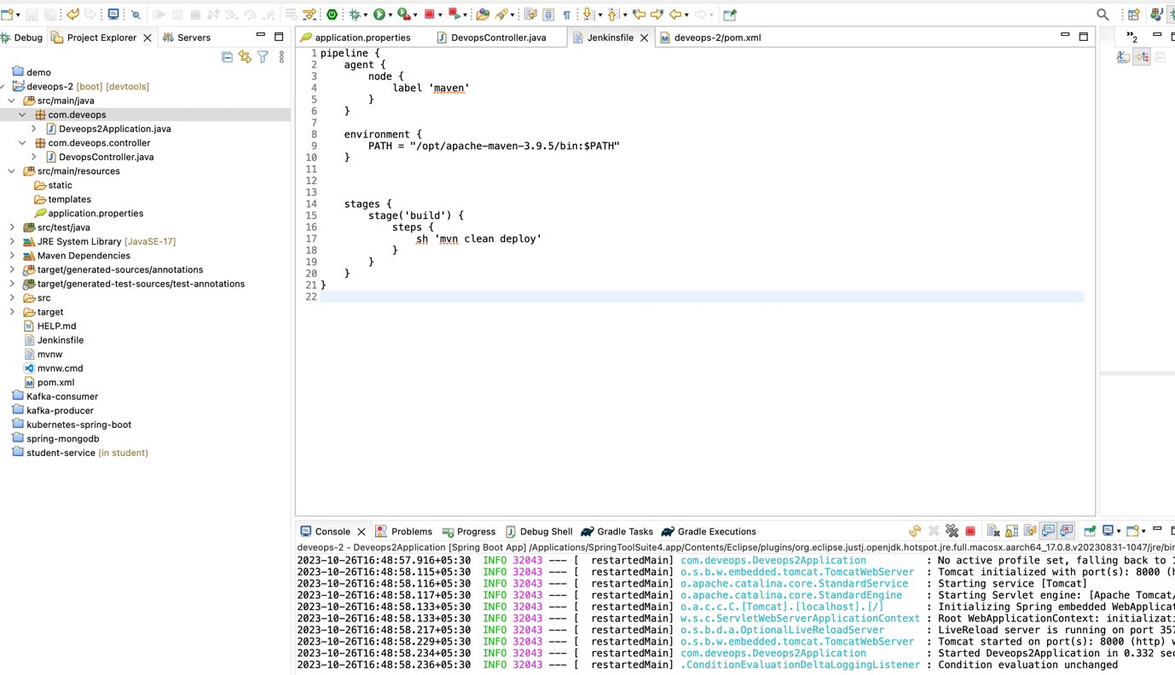

Adding GitHub credentials to Jenkins

- Create a github access token and install “multibranch scan webhook trigger”.

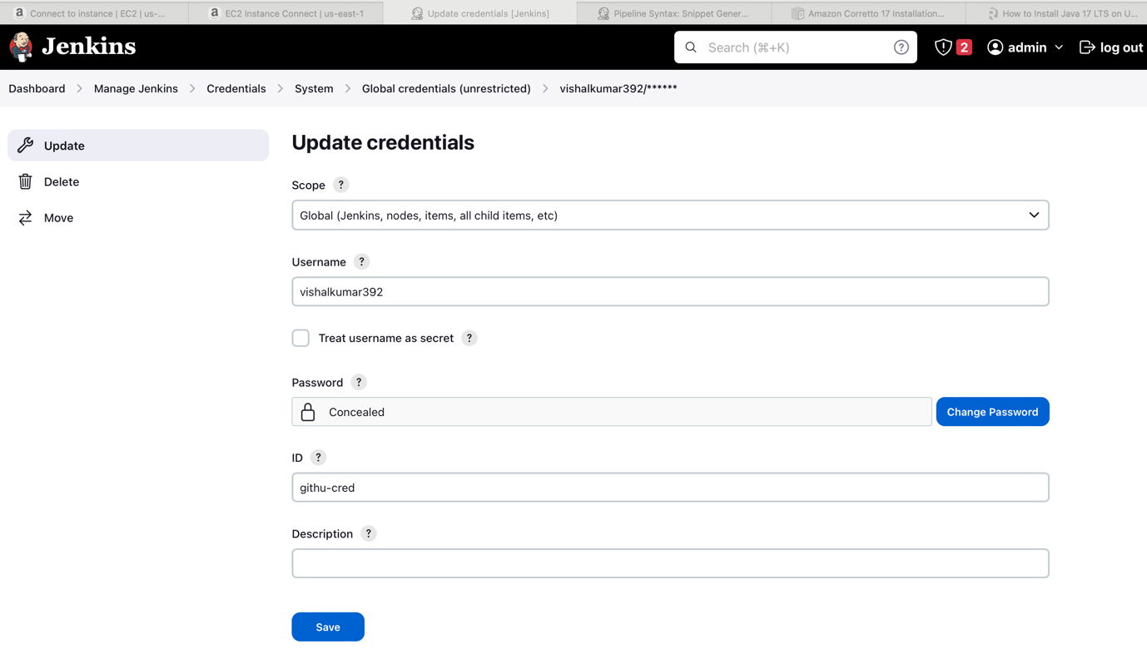

Create a Multi Branch Pipeline

- New Item/select Multibranch pipeline

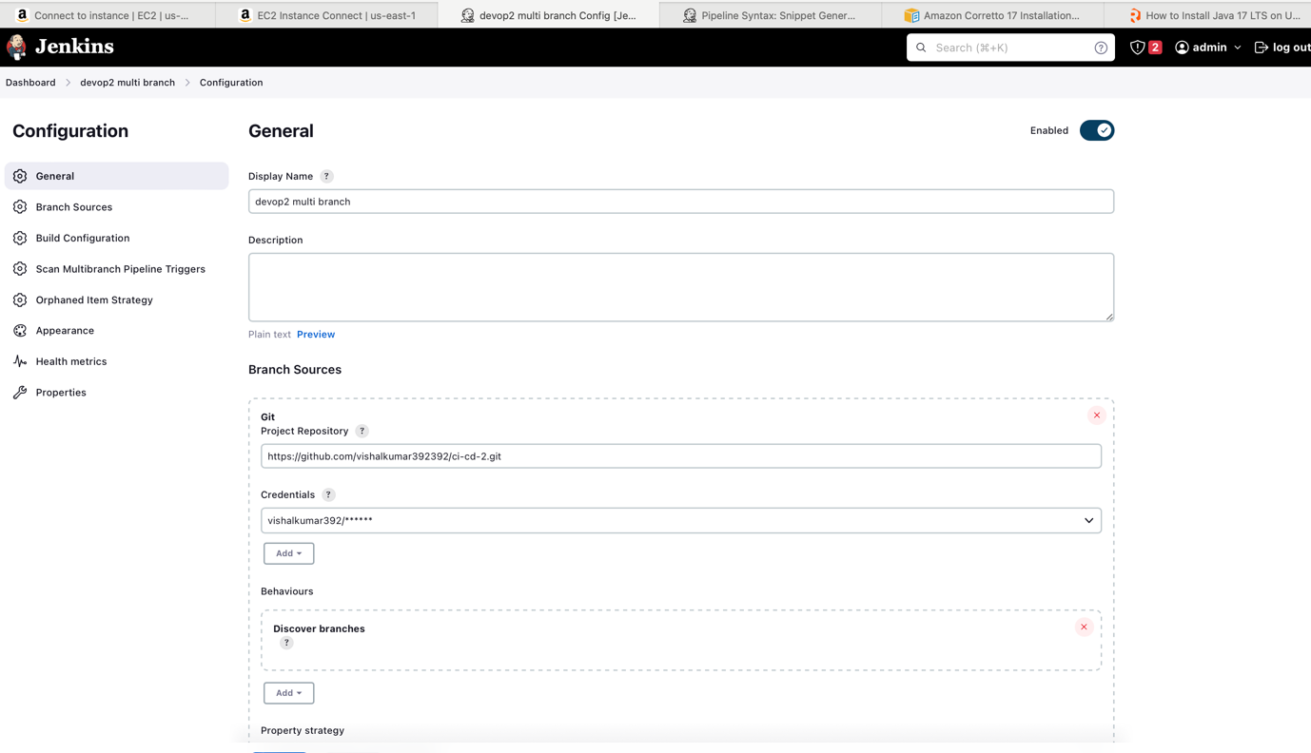

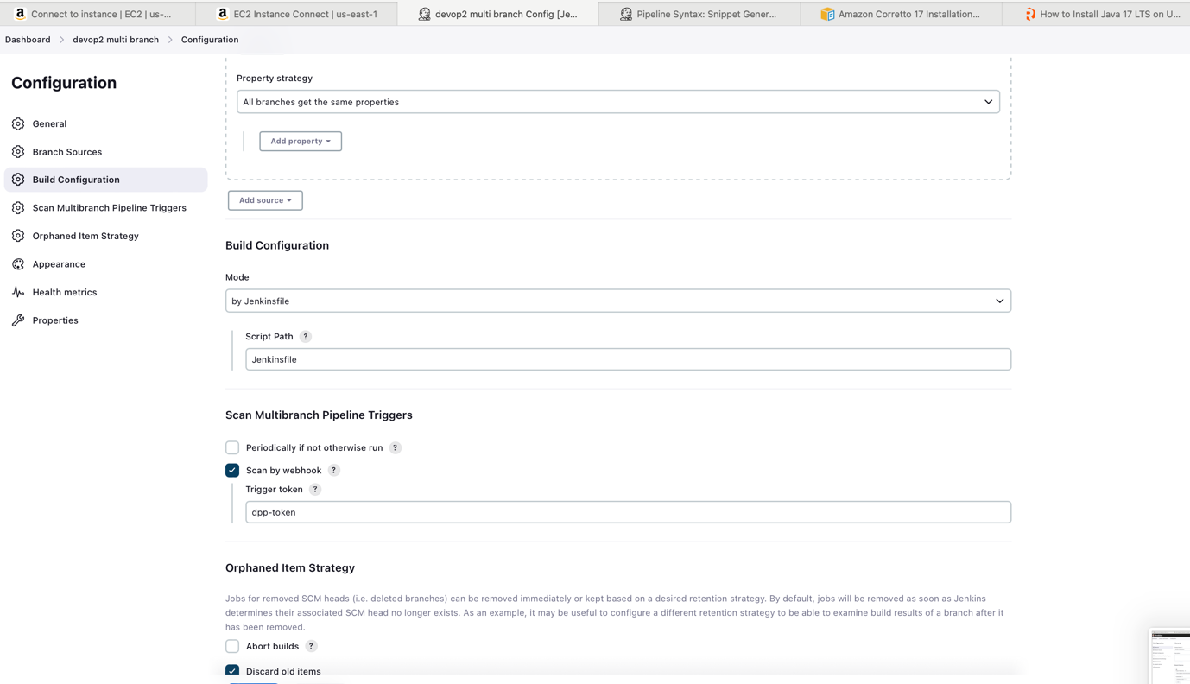

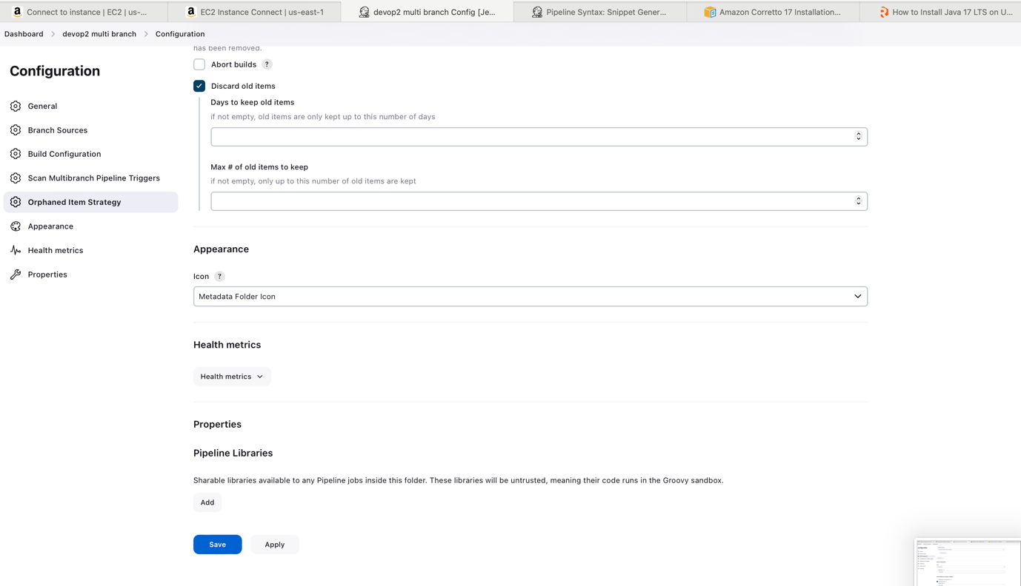

Create a web hook in git hub(reference link).

- Go to your github project repository Settings/Webhooks
- Click on Add webhook
- Under the playlood give the URL below
- http://{jenkins-server-host}/multibranch-webhook-trigger/invoke?token=dpp-token
- While creating a Multi branch pipeline section there is a section called “Scan multi branch pipeline trigeers”.
- Install Multibranch scan webhook trigger plugin in Jenkins.
- Go to multibranch pipeline job job --> configure --> Scan Multibranch Pipeline Triggers --> Scan Multibranch Pipeline Triggers --> Scan by webhook
- Trigger token: dpp-token

Section 3: Sonar Integration with jenkins

Setup Sonar Qube account and add sonar credentials to Jenkins

- Create an account at https://sonarcloud.io
- Generate an authentication token on SonarQube.
- Create credentials for token in the Jenkins.
- Download “SonarQube scanner” plugin on Jenkins.
- Configure Sonar Qube server.
- Add SonarQube scanner to Jenkins.
- Create Sonar Qube Properties file.
- Add SonarQube stage in the Jenkinsfile.

Create/Login to your sonarhub and create a accesstoken.

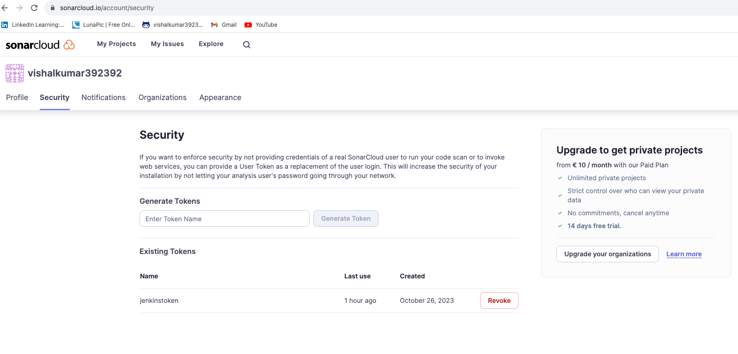

Adding Credentials to Sonar Qube.
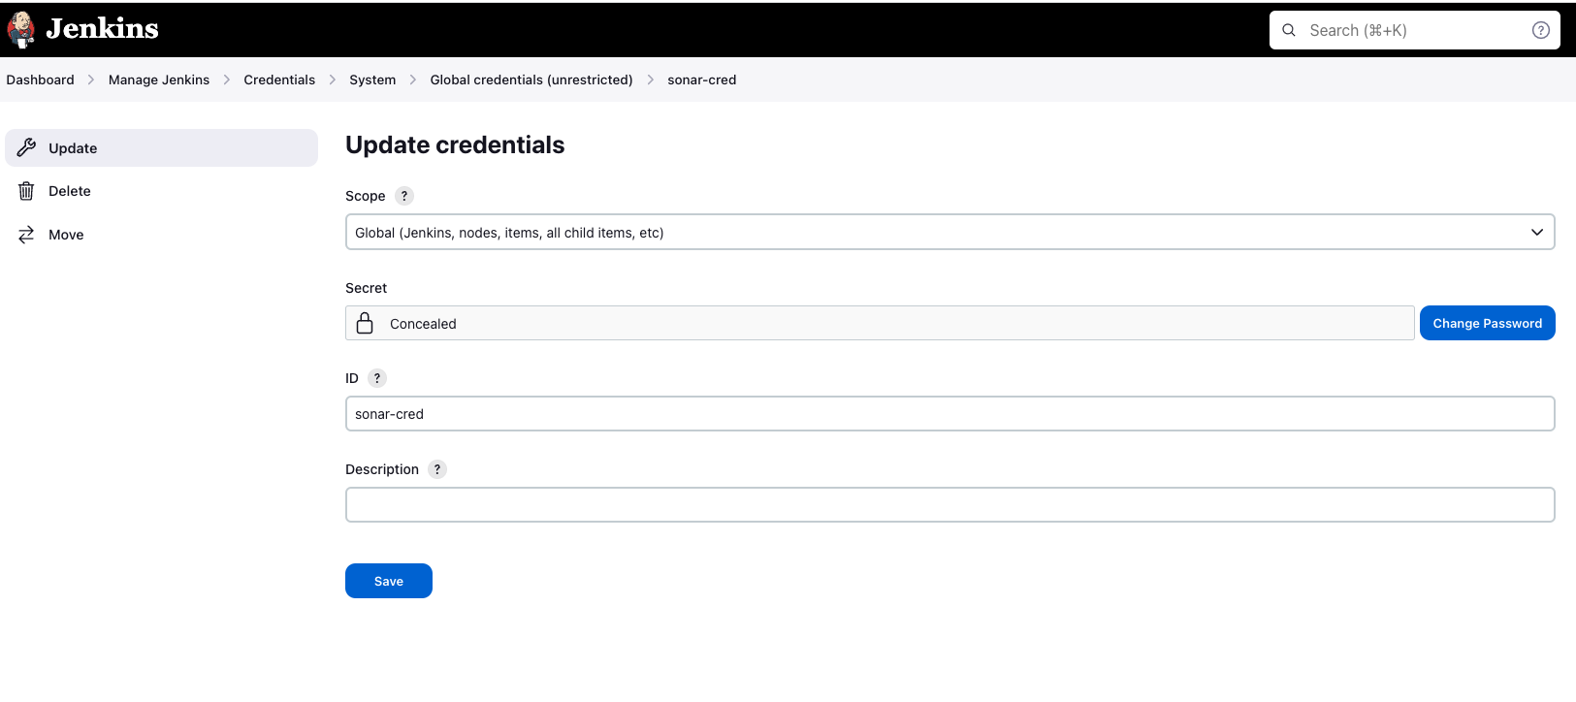
Download “SonarQube Scanner” plugin in jenkins
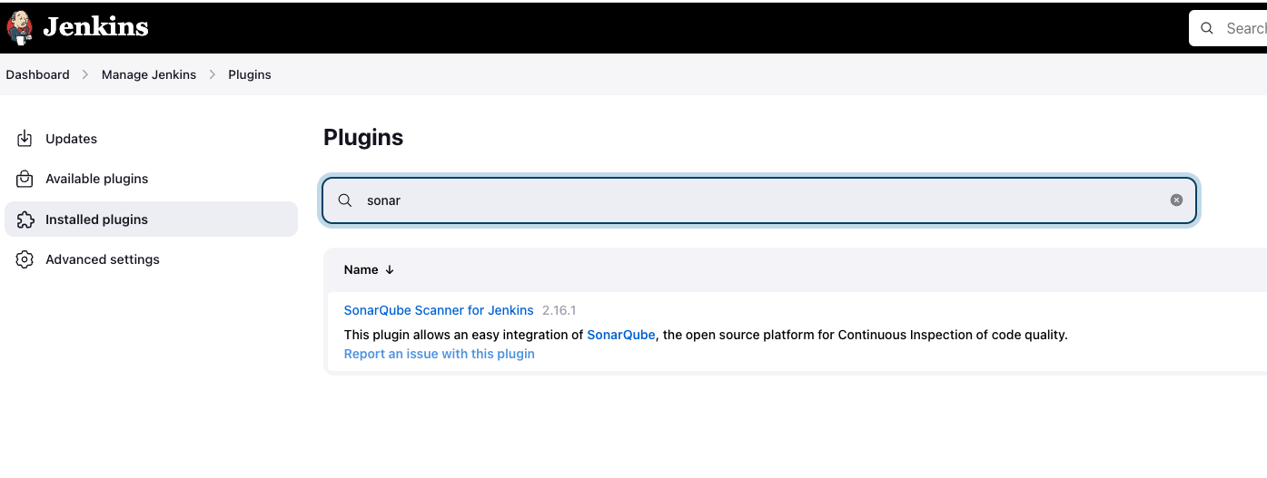
Configure Sonar qube server
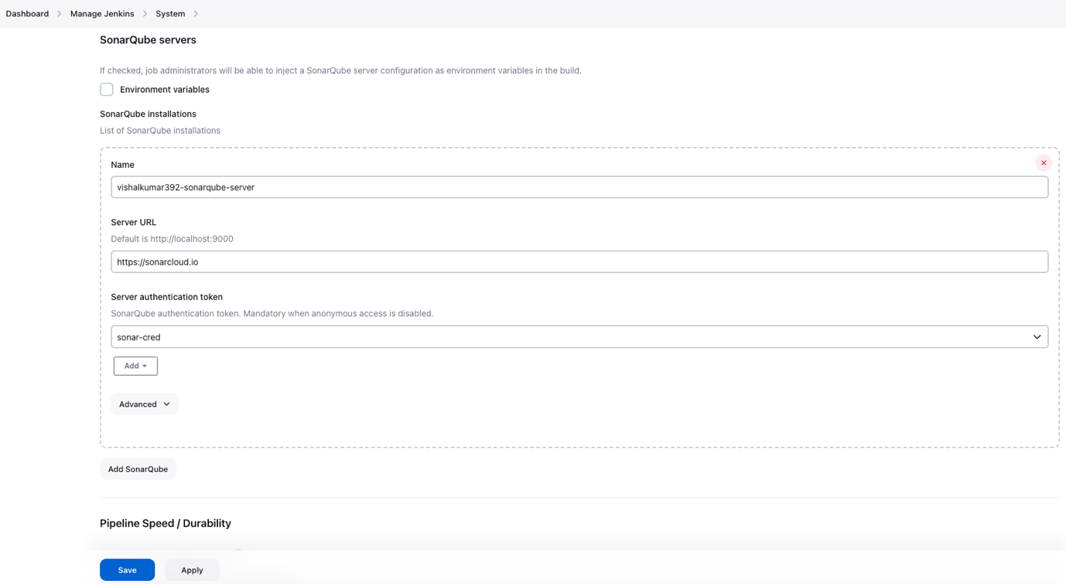

Add Sonar qube scanner to Jenkins
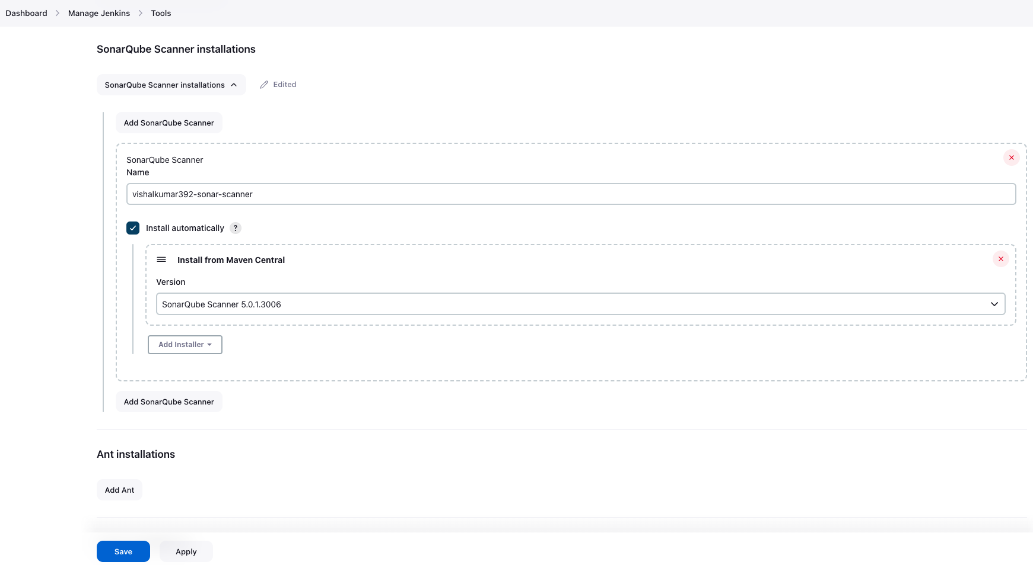

Create a Organization and project in the sonar qube

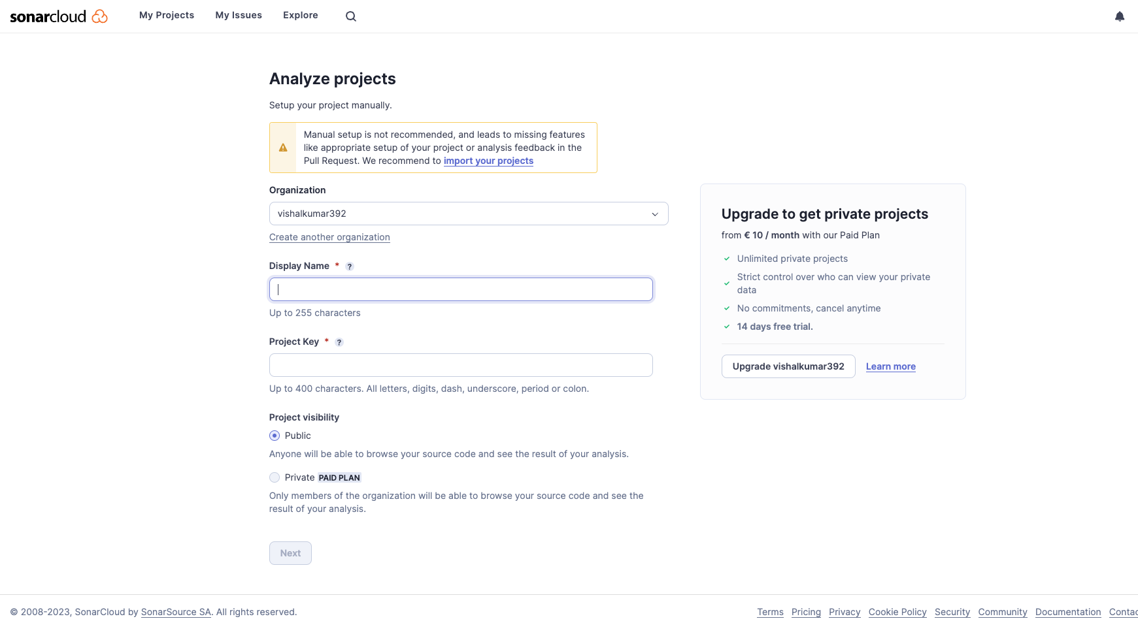

Create a sonar-project.properties file
%%%%%%%%%%%%%%%%%%%%%%%%%%%%%%%%%%%%%%%%%%%%%%%%%%%%%%%%%%%%%%%%%%%%%%%%%%%
sonar.verbose=true
sonar.organization=vishalkumar392
sonar.projectKey=vishalkumar392_devops2 // for project key refer above image
sonar.projectName=devops2
sonar.language=java
sonar.sourceEncoding=UTF-8
sonar.source=.
sonar.java.binaries=target/classes
soanr.coverage.jacoco.xmlReportPaths=target/site/jacoco/jacoco.xml
%%%%%%%%%%%%%%%%%%%%%%%%%%%%%%%%%%%%%%%%%%%%%%%%%%%%%%%%%%%%%%%%%%%%%%%%%%%

Adding SonarQube stage, unit test stage, quality gate stage
%%%%%%%%%%%%%%%%%%%%%%%%%%%%%%%%%%%%%%%%%%%%%%%%%%%%%%%%%%%%%%%%%%%%%%%%%%%
pipeline {
agent {
node {
label 'maven'
}
}

environment {
PATH = "/opt/apache-maven-3.9.5/bin:$PATH"
}

stages {
stage('build') {
steps {
echo '-----------build started---------------'
sh 'mvn clean deploy -Dmaven.test.skip=true'
echo '-----------build completed---------------'
}
}
stage('test') {
steps {
echo '-----------unit test started---------------'
sh 'mvn surefire-report:report'
echo '-----------unit test completed---------------'
}
}
stage('SonarQube analysis') {
environment {
scannerHome = tool 'vishalkumar392-sonar-scanner'
}
steps{
withSonarQubeEnv('vishalkumar392-sonarqube-server') { // If you have configured more than one global server connection, you can specify its name
sh "${scannerHome}/bin/sonar-scanner"
}
}
}
stage("Quality Gate"){
steps {
script {
timeout(time: 1, unit: 'HOURS') { // Just in case something goes wrong, pipeline will be killed after a timeout
def qg = waitForQualityGate() // Reuse taskId previously collected by withSonarQubeEnv
if (qg.status != 'OK') {
error "Pipeline aborted due to quality gate failure: ${qg.status}"
}
}
}
}
}
}
}
%%%%%%%%%%%%%%%%%%%%%%%%%%%%%%%%%%%%%%%%%%%%%%%%%%%%%%%%%%%%%%%%%%%%%%%%%%%

Section: 4 Jfrog Artifactory Integration with Jenkins

- Create a Artifactory account.
- Generate a access token with username
- Add username and credentials under Jenkins credentials.
- Install Artifactory plugin.
- Update Jenkins file with jar publish stage
- Create a Dockerfile.
- Create and publish docker image on Artifactory.

Create a Jfrog artifactory Enterprice account, we will get 14 days free trial.

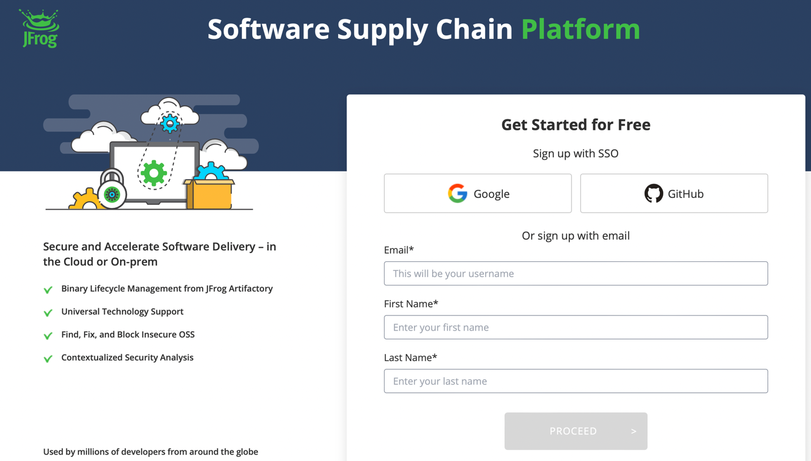

Intial web page of Jfrog Artifactory

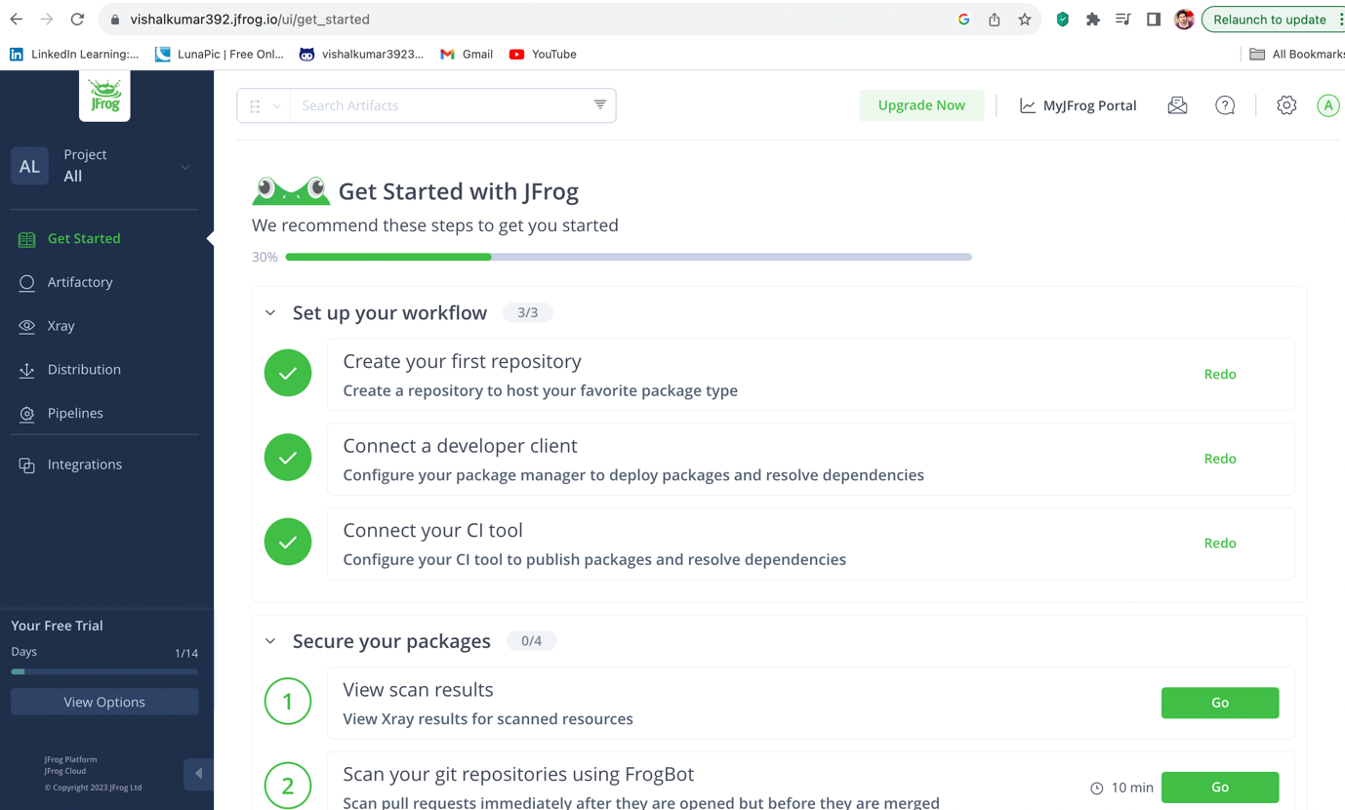

Create a acccess token
Click on top right cornor settings icon and select User Management option

Username should be email of the jfrog account and store the access token in a note pad.
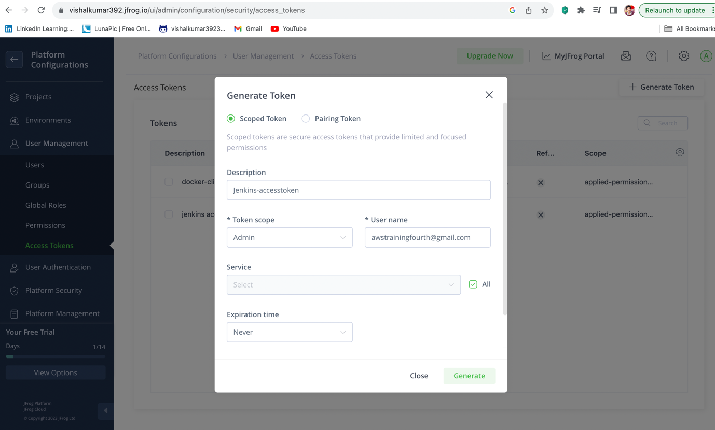

Add username and credentials under Jenkins credentials.
Remember ID, it is very important.
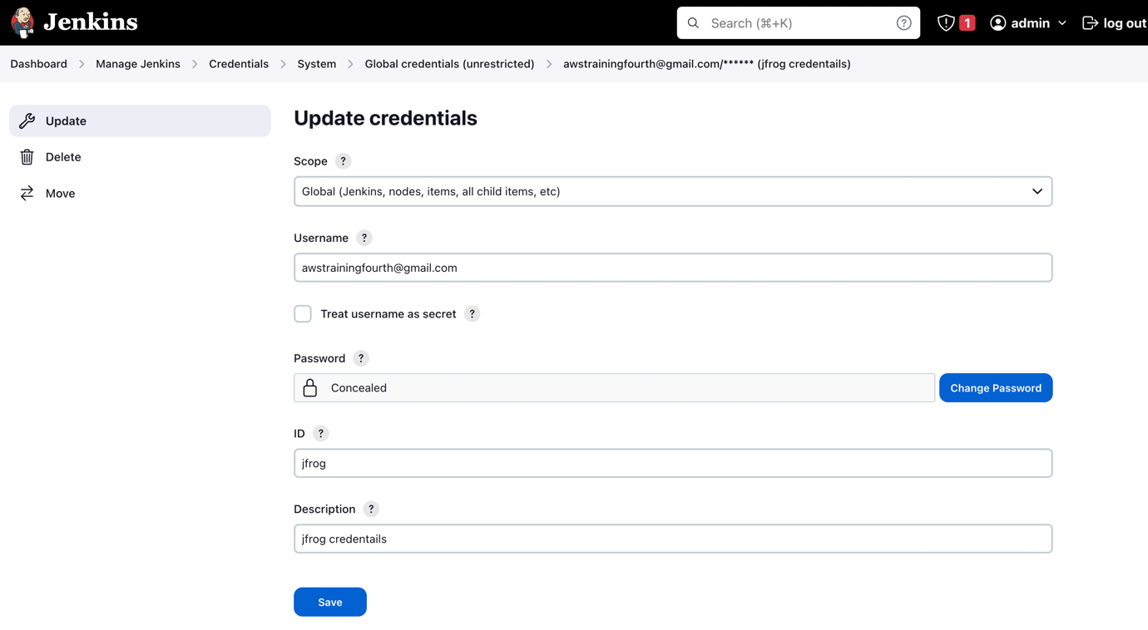

Install Artifactory plugin.

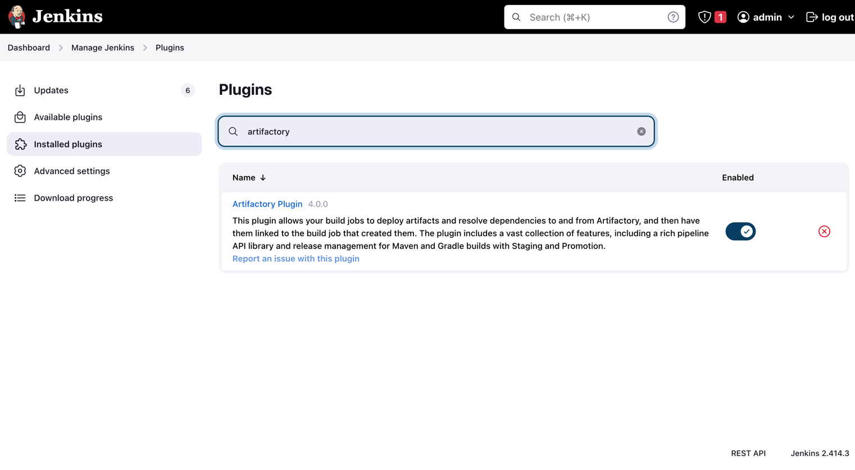

Update Jenkins file with jar publish stage

Below Details are required.
jfrog: https://vishalkumar392.jfrog.io/
location: /home/ubuntu/jenkins/workspace/devop2-multibranch_main/jarstaging/com/deveops/deveops-2/0.0.1-SNAPSHOT
credentials: jfrog (jenkins credentials id)

Follow this link for reference. In this author mentioned the steps to be taken care.

Follow this link for my updated jenkins file code in my github repository.

After updating the jenkinsfile and pushing the code, see the pipeline running status. After pipeline successfully finished we can observe the artifact in Jfrog.

Below we can observe the updated jenkins pipeline image.
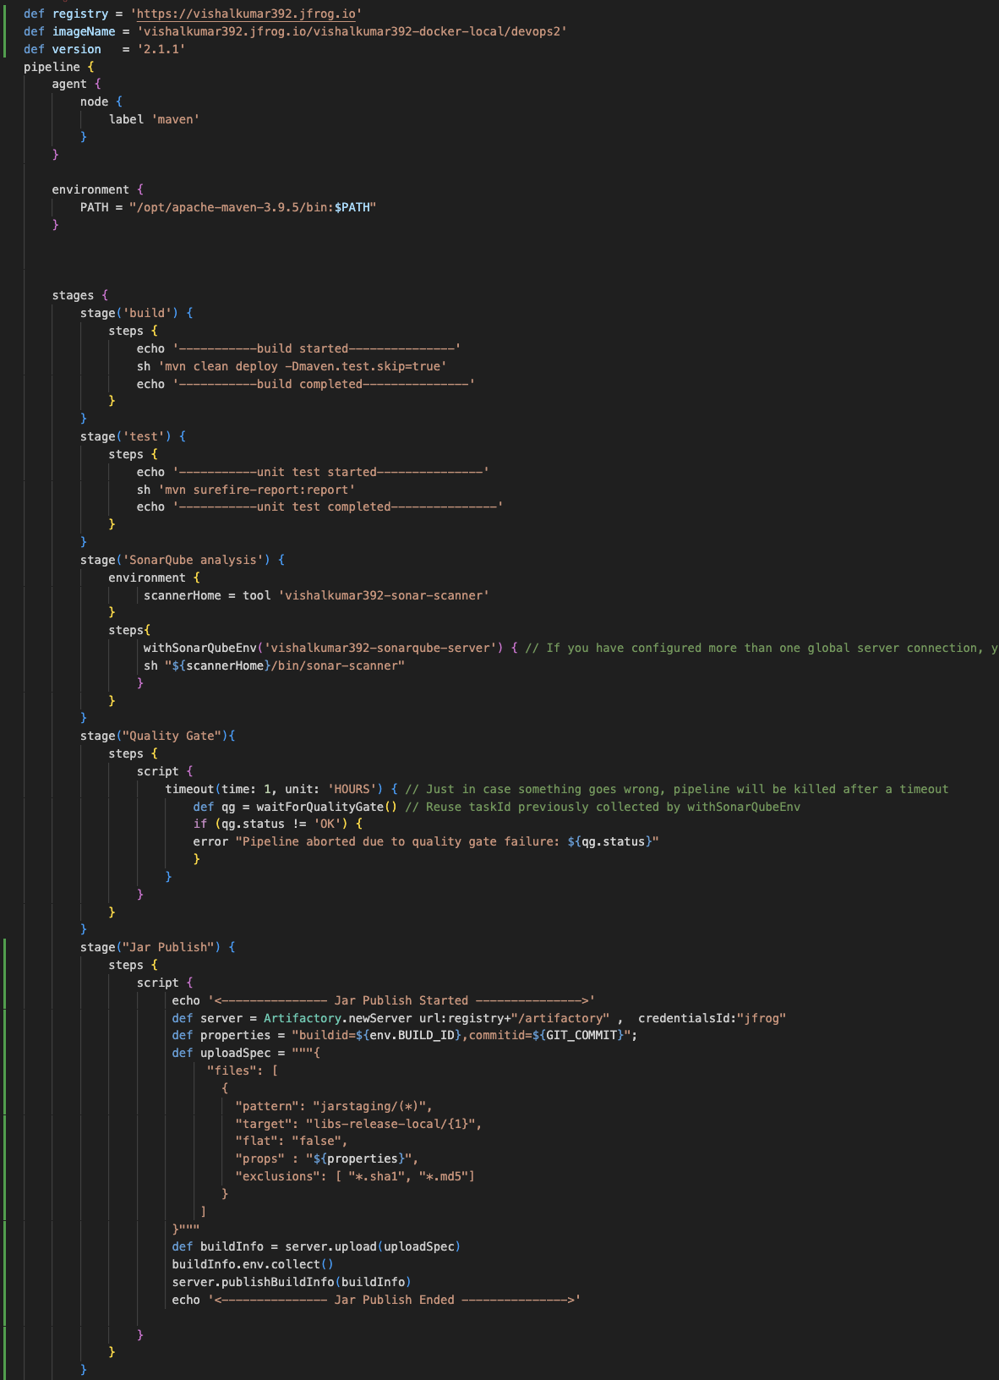

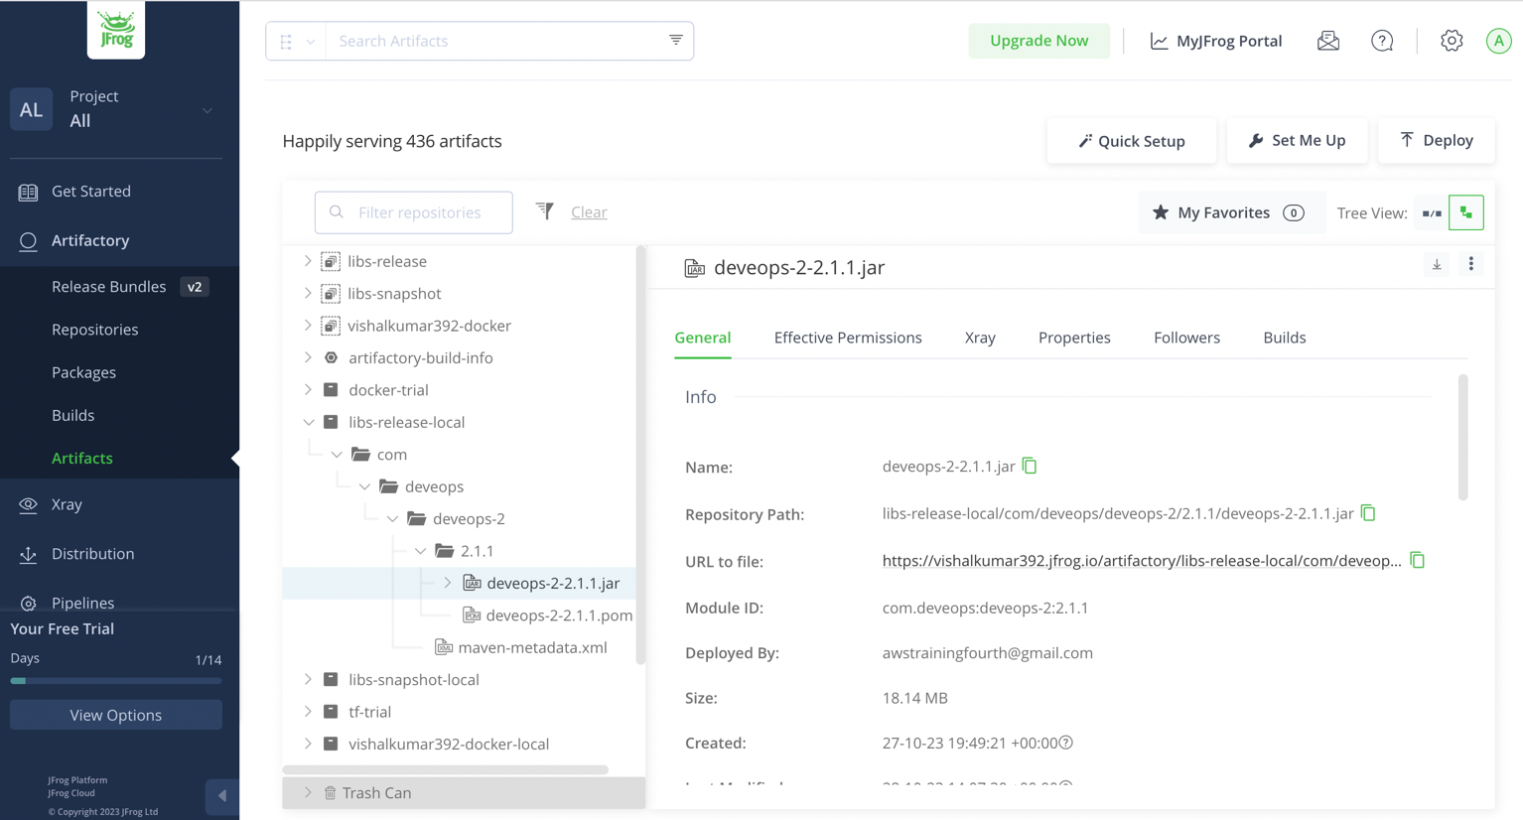

Update Ansible playbook jenkins-slave to install docker on slave server.

- name: install docker
apt:
name: docker.io
state: present

- name: start docker services
service:
name: docker
state: started

- name: give 777 permissions on /var/run/docker.sock
file:
path: /var/run/docker.sock
state: file
mode: 0777

- name: start docker on boot time
service:
name: docker
enabled: yes

Create a Dockerfile in the Project.
Follow this link for author document.
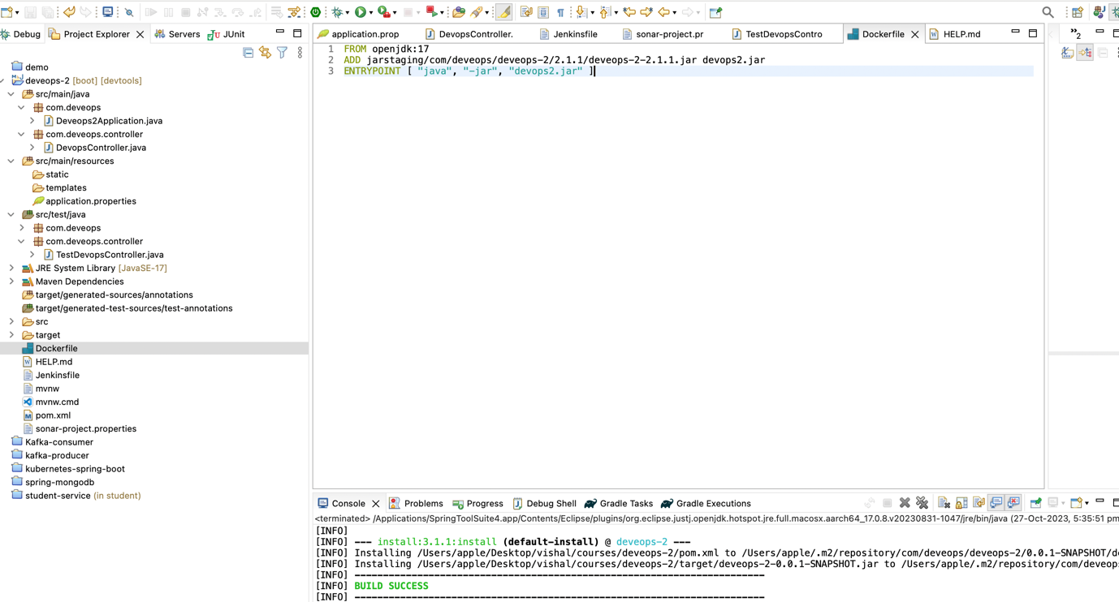

Create a docker artifact in Jfrog

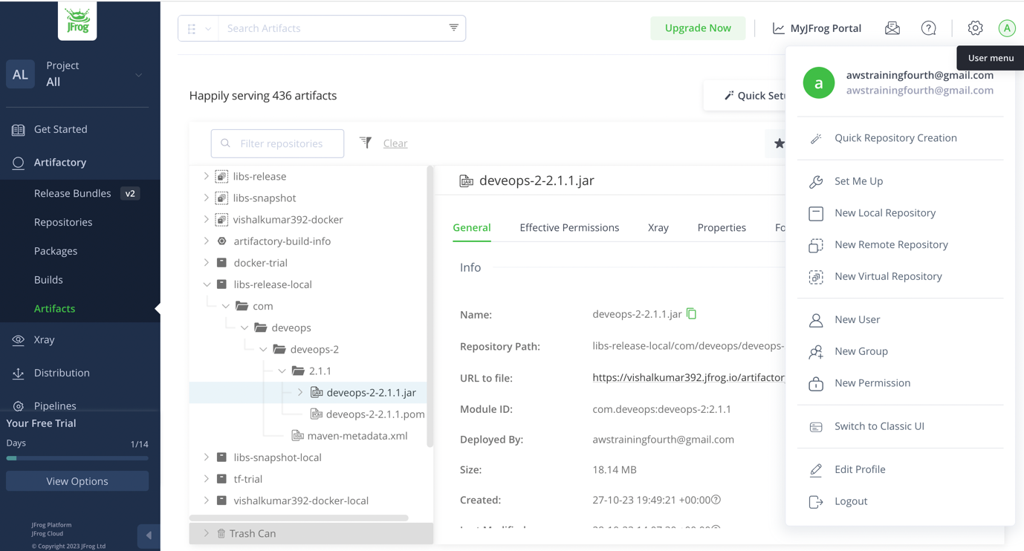

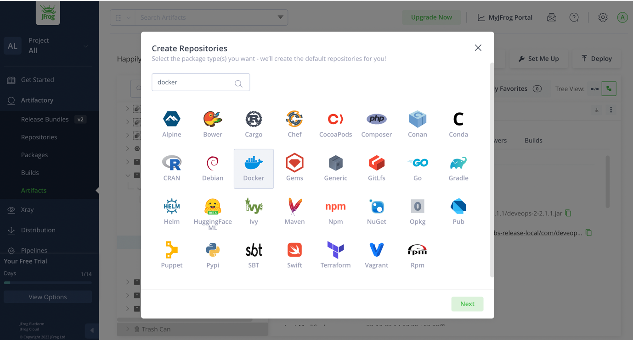

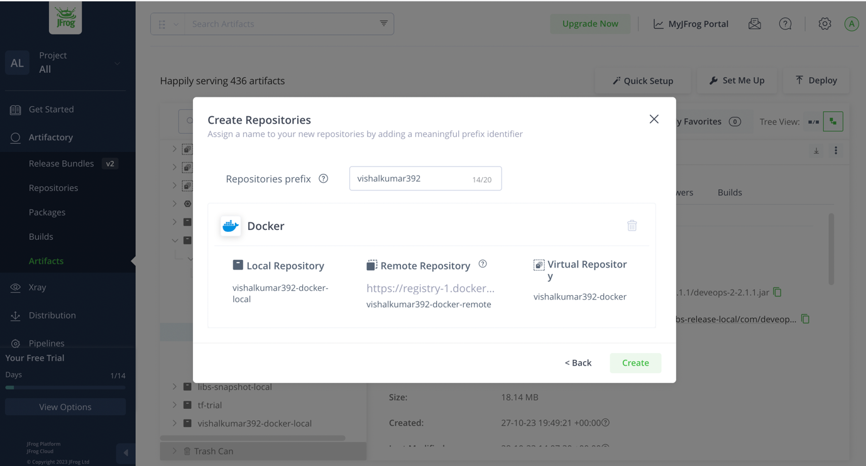

Install the docker pipeline plugin in jenkins

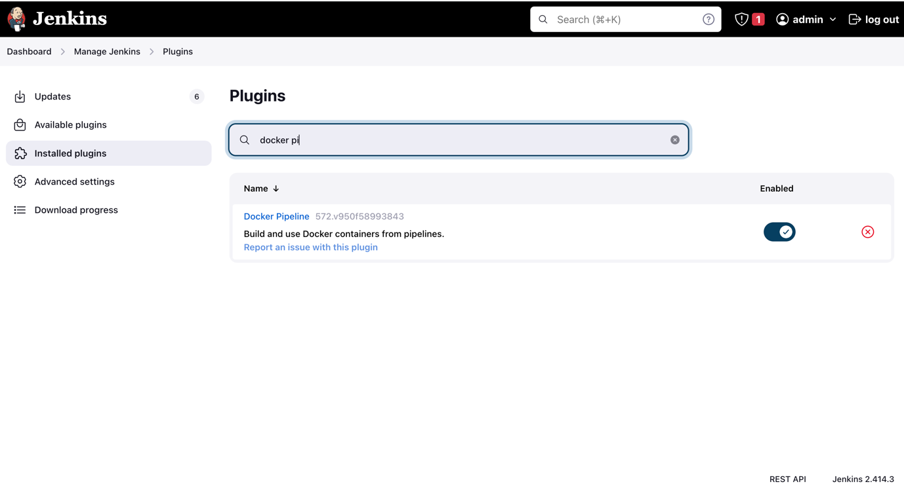

Update the Jenkinsfile stage to build and publish the docker image

Follow this link for author documentation.

stage(" Docker Build ") {
steps {
script {
echo '<--------------- Docker Build Started --------------->'
app = docker.build(imageName+":"+version)
echo '<--------------- Docker Build Ends --------------->'
}
}
}

stage (" Docker Publish "){
steps {
script {
echo '<--------------- Docker Publish Started --------------->'
docker.withRegistry(registry, 'jfrog'){
app.push()
}
echo '<--------------- Docker Publish Ended --------------->'
}
}
}

Push the code and see the jfrog docker artifactory, there will be a artifact.

Kubernetes Integration in slave server as ubuntu user

- Installing EKS cluster in AWS using terraform script. Run this script using command “terrraform apply –auto-approve”.

- It will take some time and it will create the cluster in your VPC.

- Integrate build server/jenkins-slave/Maven-server with Kubernetes cluster. Link

- Integrate Jfrog with kuberenetes cluster, if not mainfest files which we execute in worker nodes cant pull the images from Jfrog. Link

- Create a new user in the Jfrog.

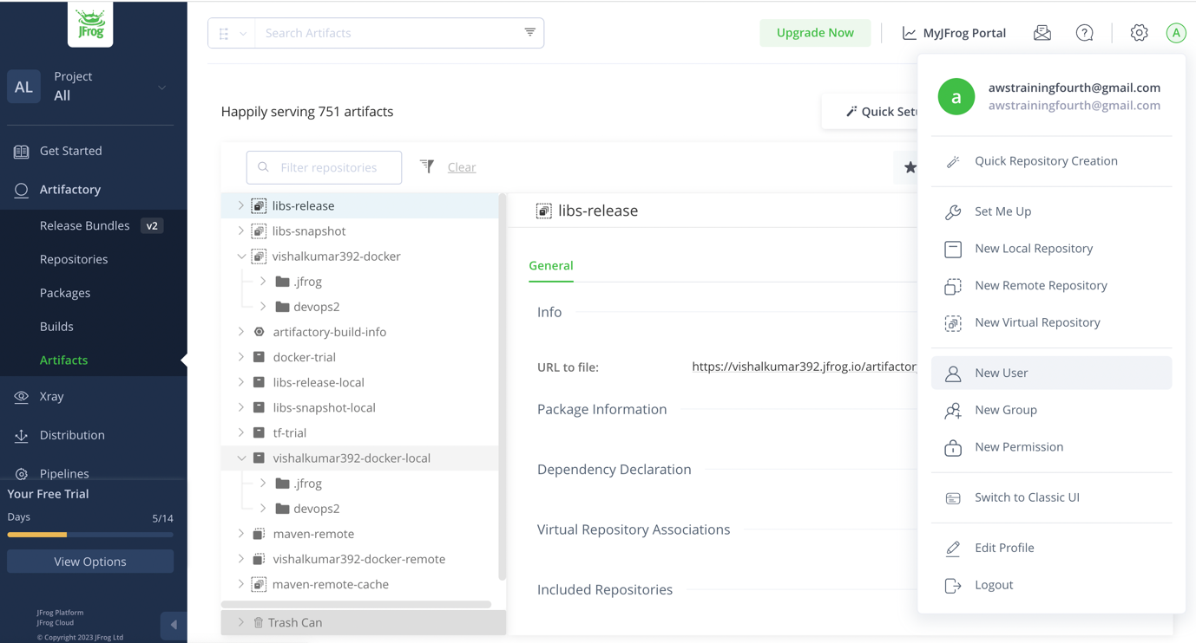

- Execute command “docker login https://vishalkumar392.jfrog.io/” and give the newly created user name and password.
- Then execute “cat ~/.docker/config.json | base64 -w0”, this command will give you encoded string.
- Create manifest files i.e service.yaml, deployment.yaml, deploy.sh, secrets.yaml.
- In secrets.yaml file, under dockerconfig.sort paste the above encoded string.
- Commit those manifest files in your code. And update a new stage in the Jenkinsfile.
- By default slave sever run as ubuntu when jenkins triggers the Jenkins build, that is the reason I recommended to install the kubectl and awscliv2 in ubuntu.
- Push the code after updating the Jenkinsfile.
- After pushing because of webhook the jenkins will trigger and pipeline will start, once the pipeline is finished new deployment and service is created in the cluster and our code is running inside a pod in a container. Access the endpoints using loadbalancer url.

